**STRUCTURE AND DYNAMIC MEMORY MANAGEMENT**

**1. Refer the question 1 solved in “Structure and function”. Extend the above program to read a number of records from the user as a single command line argument (each record is delimited by a semicolon and record fields are delimited by comma) and store in an array of structures.**

**Sample input and output are given below.**

**Input: “user1,90;user21,100, userABC,56,userX,40”;**

**Output:**

**No. of records: 4**

**Record 1:**

**Name:user1, Percentage:90**

**Record 2:**

**Name:user21, Percentage:100**

**Record 3:**

**Name:userABC, Percentage:56**

**Record 4:**

**Name:userX, Percentage:40**

**Implement all required functions and call them to get the desired output.**

**Check for memory leak.**

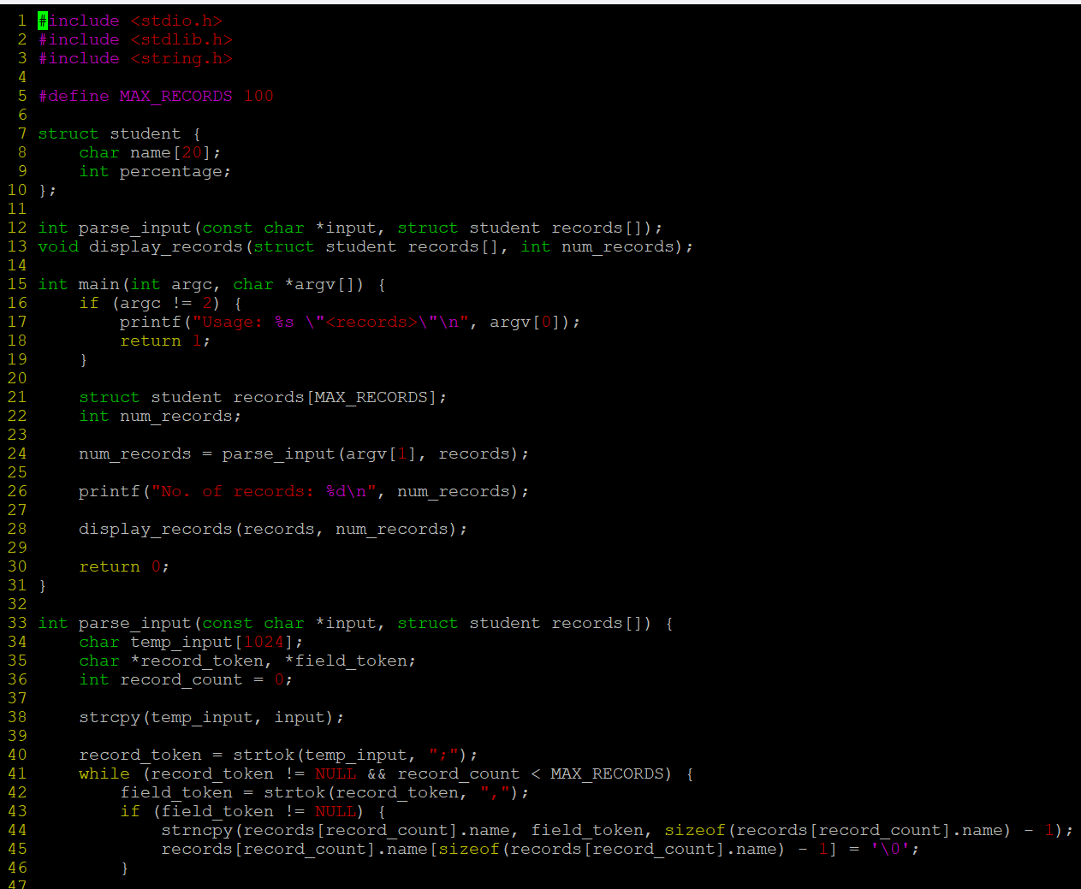

**OUTPUT:**

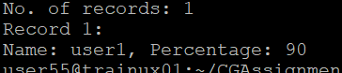

**2. Extend Q1. Above and add 3 functions below.**

**//to search for a name and to replace it with a user defined name, return replaced string**

**char*search_update(char *searchstr, char *replacestr);**

**//search and delete the record with given name or percentage value, return SUCCESS on successful delete else FAILURE**

**int delete_record(char *searchstr, int percent);**

**//search for name and if found create a copy of the record in newstudent**

**and return SUCCESS, else FAILURE**

**int copy(char *name, struct student **newstudent);**

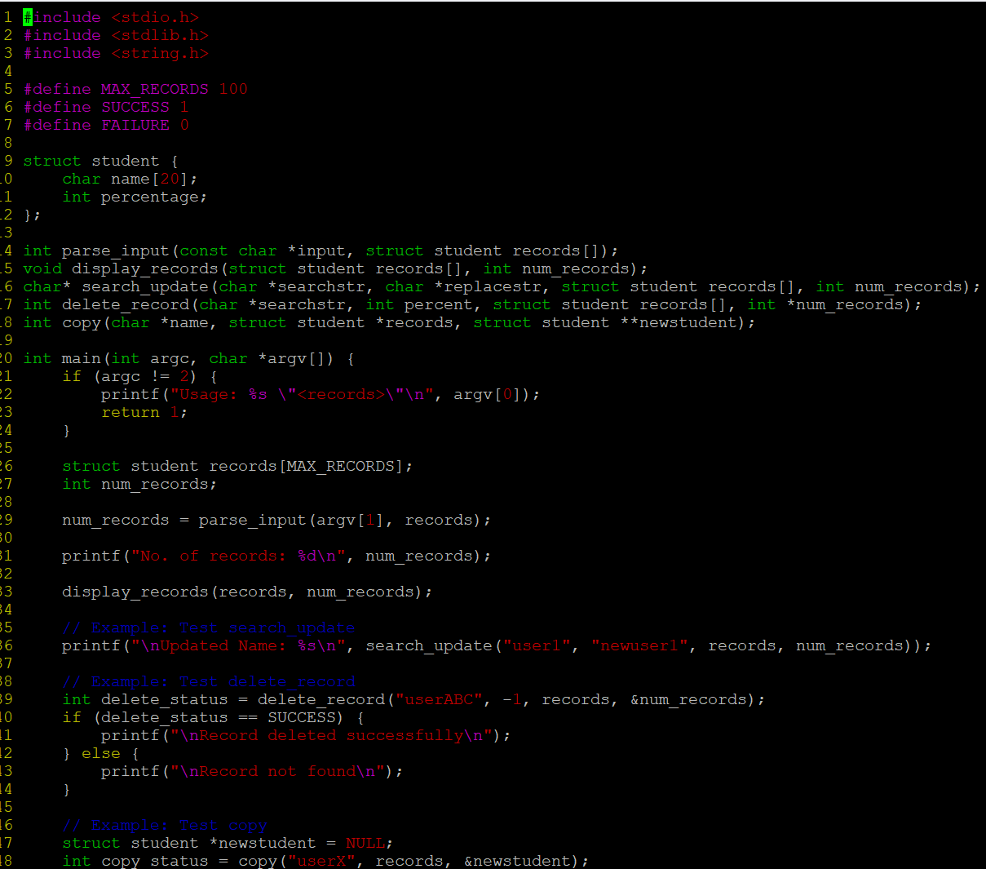

**OUTPUT:**

